

# Quality Improvement Plan (QIP) Narrative for Health Care Organizations in Ontario

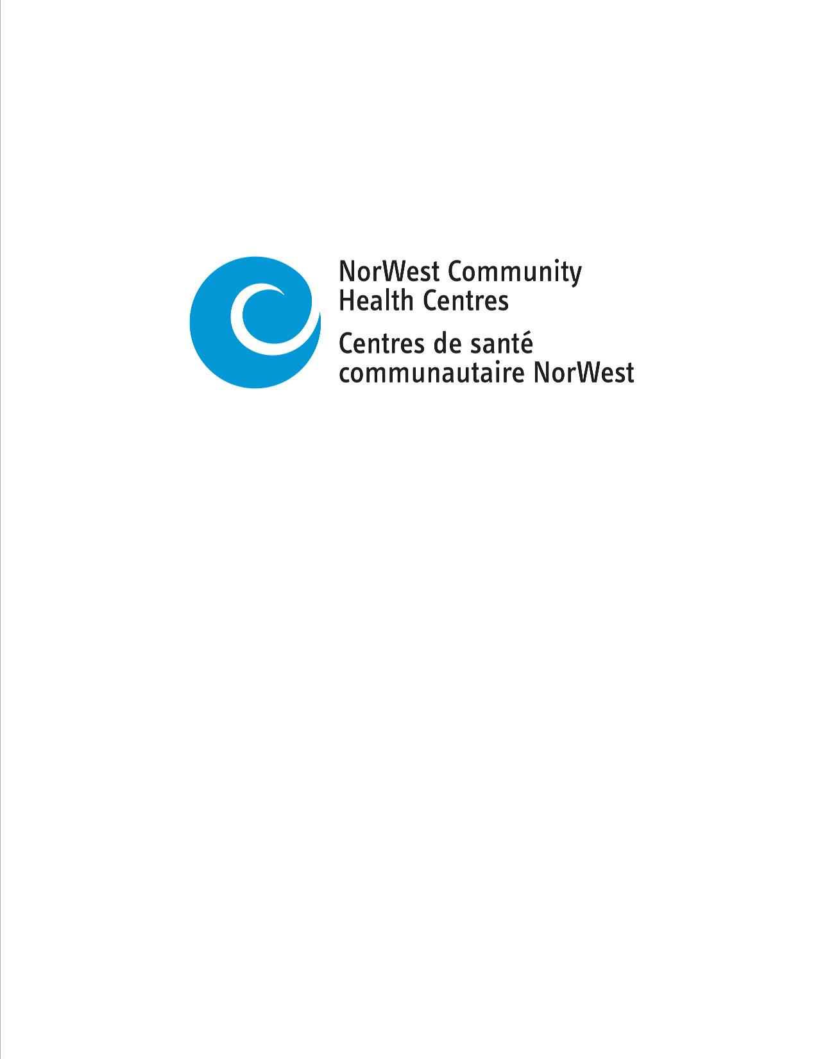

**2/12/2020**

This document is intended to provide health care organizations in Ontario with guidance as to how they can develop a Quality Improvement Plan. While much effort and care has gone into preparing this document, this document should not be relied on as legal advice and organizations should consult with their legal, governance and other relevant advisors as appropriate in preparing their quality improvement plans. Furthermore, organizations are free to design their own public quality improvement plans using alternative formats and contents, provided that they submit a version of their quality improvement plan to Health Quality Ontario (if required) in the format described herein.

Province of Ontario brand mark
ontario.ca/excellentcare

## Overview

NorWest Community Health Centres (NWCHC)exists to provide the people of Northwest Ontario with a safe and judgement free environment to receive a wide range of health services. The core values of NWCHC focus on promoting the social determinate of health, social justice; improving accessible and overcoming system-based barriers; providing holistic care; promoting diversity and inclusion; and providing care to high-risk and vulnerable populations.

NWCHC continues to service individuals at the three main sites in Thunder Bay, Longlac and Armstrong; and provide mobile services to many outlying communities including Neebing, Nolalu, Kaministiquia, Shebandowan, Upsala, O’Connor, Murillo, Armstrong. As well, through collaboration with community partners NWCHC is also able to offer additional holistic services at Family Health Teams, low-income housing complexes and homeless shelters across the city.

In 2019/20 NWCHC’s main quality improvement focus was on the development of new processes and collection of baseline data for four of the six priority indicators on the QIP. A collaborative effort between the Quality Improvement Lead, Primary Care Leadership and Data Analytics resulted in an established baseline for post hospital discharge follow-up and opioid Prescribing practices.

A new practice for holistic care planning for palliative clients was in development, but was put on hold due to the announcement of a new regional palliative care program that would be led by NWCHC. As of Q4 the new Manager of Palliative Care has established targets for the next fiscal year and worked with program partners to finalize a client pathway for the program. This work has set the program up for successful launch in April 2020.

For the two remaining indicators focusing on client experience, NWCHC worked to refine its data collection methods and ensure that results are more accurate. The Centre also implemented a new automated phone tree system to ensure that client calls are not missed and daily reminder calls are made to clients to ensure they are aware of upcoming appointments. The result of this work is a reduced number of no-shows for appointments which has helped ensure a better utilization rate for appointment times.

Lastly, a ‘client appointment guide’ pilot project was conducted and clients were given an info-graph providing guidance on how to get the most out of their primary care visit and engage their primary care provider in their care plan. As well clients are now provided with calendars to keep track of their appointments and their personal health information in order to ensure they are aware of their health plan.

For 2020/21 NWCHC looks to align quality within the strategic framework of the organization, and ensure that operational plans for the year align with the QIP priority indicators. In order to ensure the success of the QIP, the organization will look to focus on a number of core quality initiatives that will improve services to our clients and respecting their wishes and desires for their individual care plans. NWCHC’s will look to embed quality in all processes through the introduction of LEAN methodology and engagement of all levels of staff in process improvement to ensure that solutions are developed with those most responsible for the work.

## Describe your organization's greatest QI achievement from the past year

**INTEGRATION OF QUALITY AND STRATEGY**

In 2019/20 NWCHC worked with the board of directors, staff and community stakeholders to establish a strategic plan for the organization. Part of the mandate of this strategic plan is to ensure that quality is embedded in all work at the organization. The main objective of this work is to ensure that decision-making within the organization aligns quality improvement initiatives with corporate planning and key operational projects.

Within this work is the goal of developing a Quality Improvement Plan (QIP) and major quality initiatives as part of the annual planning cycle and ensure the QIP guides the development, implementation, monitoring and evaluation of quality improvement efforts throughout the organization. The QIP should provide a framework for NWCHC senior management team to enhance the culture of quality within the organization and to ensure QI, MSAA, funder’s targets and accreditation standards are met. Its focus will be on priority QI drivers as means to achieve NWCHC’s goals in the following:

* Providing organizational leadership by using evidence to identify opportunities for improvements;
* Developing and implementing continuous process improvement actions within corporate planning;
* Building organizational capacity;
* Enhancing communication for performance improvement and staff motivation;
* Advancing a culture of quality and high performance within the organization.

Enablers to Improve Operational Capacity for Performance Improvement

As a result of the vision and activities outlined in this plan, NWCHC will be better able to protect, maintain and improve the health of our community as a result of the implementation of the CHC model of Health and Wellbeing.

**RAPID ACCESS ADDICTIONS MEDICINE (RAAM)**

In an effort to improve the health and well-being of individuals in our community, NWCHC partnered with five other agencies to develop and implement the Rapid Access Addiction Medicine Clinic. RAAM is offers clients who are seeks treatment for substance abuse issues a safe, healing and judgement free environment to receive services.

For 2019/20 the RAAM clinic saw considerable growth in the number of new clients accessing services. In the 3rd quarter 146 new clients access services and the clinic saw 1,063 total service encounters. For the first nine months of 2019/20 there was a total of 3,293 service encounters.

The RAAM clinic team is committed its clients first and foremost. This is demonstrated though effective engagement and creating an environment that welcomes and supports clients with diverse backgrounds, providing care that is culturally appropriate and providing evidence based care with team members from various backgrounds. RAAM leadership and team members recognized and believe in the values of integrating peer led approaches and indigenous practices into the model of care. The RAAM team have been able to transcend organizational boundaries and been able to effectively utilize their collaborative expertise to support the client and their identified need.

The RAAM team has been able to overcome many challenges, however continues to focus on celebrating the successes of each client no matter how big or small these successes may seem. The team continues to look towards the future, specifically with regards to how they might be able to respectfully bring forward the human voices of and experiences of clients in an effort to reduce stigma and discrimination in our community.

**PATH525: CONSUMPTION TREATMENT SERVICES**

Path525 started in November 2018 as a small scale pilot project for overdose prevention. The mandate of the program is to provide a safe, supervised environment for clients to come and use illicit substances in the hope of reducing overdoes and use of emergency services. The initial program consisted of one registered nurse, and one support worker. In the first month of actually seeing clients (January 2019) the clinic saw only 15 individuals for a total of 33 visits.

Since this time the program has grown to include a full range of harm reduction services, offers education on safe consumption of substances and it offers clients a chance to connect with addiction services or social services if they are interested.

As of December 2019, use of the services at Path525 has increase to 419 visits for 119 unique clients. As well the staffing has grown to two registered nurses, 2 support workers, 2 outreach workers and a full time supervisor. The site is now open 7 days a week to offer full supports to clients. The full range of services offered support these clients in a variety of different ways including mental health needs, food or personal supplies and harm reduction supplies. The staff will also help clients access any primary care needs, social assistance or mental health services they require. The hard work of the staff at Path525 has contributed to no deaths related to overdoses for the 2,729 visits at the clinic in 2019.

## Collaboration and integration

**MANAGE ALCOHOL PROGRAM (MAPS)**

NWCHC continues to partner with Shelter Health and Dilico Anishinabek Family Care to support the Manage Alcohol Program through Kwae Kii Win (KKW) at Shelter House. MAPs is part of the overall harm reduction strategy that incorporates safe accommodation for homeless individuals dealing with severe alcohol use disorder. The objective of this program is to increase equitable access to care for vulnerable individuals by providing walk-in clinics and provisional primary care.

In first eight months of 2019/20 the MAPs program serviced 22 individual clients through 376 individual service interactions. Services provided to these clients include access to specialists, medication management, dispensing of medication, wound care, vaccinations and management of chronic conditions. The enhanced KKW health care team provides holistic, team-based and client centred care to vulnerable individuals who would normally face issues accessing the care they require due to their transient nature.

**TEAM CARE**

The Team Care program continues to work with three Primary Care Clinics in Thunder Bay to provide access to expanded services for system navigation, dietary care, mental health therapy, health promotion, and foot care to the clients for these clinics.

Having completed its first full year of service, Team Care is now focused on working with clinic management and physicians to promote access and expand the number of clients utilizing the services provided. Through a collaborative approach between NWCHC and the clinics, a series of quality meetings were established to review results for the number of clients served, develop strategies to find new ways to reach clients, promote new programs and ensure that the services delivered are meeting the needs of all involved. Over the course of 2019/20 this work has resulted in an increase in service interactions provided from 944 in Q1 to 1,423 in Q3.

Overall the Team Care program continues to provide many valuable services to clients of the primary care clients.

**SCREENING FOR LIFE CLINIC**

In partnership with the Thunder Bay District Health Unit, Elevate, Prevention and Screening Services at the Thunder Bay Regional Health Sciences Centre and Grace Place, NWCHC delivered a screening and testing day at Grace Place during their well-accessed meal program. The goal was to deliver an all-encompassing health care day. This collaboration of services was a cross-sector model of health care delivery that drew on the different strengths of health and social services to create an innovative, low-barrier pathway through which people can engage with a range of providers and complete multiple screenings/tests in one day.

Interested clients who under normal circumstances may not have regular access to health services were able to receive screening and tests. Ontario Works and the Ontario Disability Support Program agreed to have staff available on their phones for the day of the event so staff could call and get the required information to complete requisitions (with the consent of the client). The screening day was an ideal scenario for individuals who had several outstanding screens to complete, but have a hard time keeping appointments.

Over the course of the screening day more than 120 clients were seen and a variety of services including immunizations, HIV testing, mammograms, STI screenings, colorectal FIT tests were completed. As well clients were provided with clothing supplies, and bus tickets.

## Patient/client/resident partnering and relations

**CLIENT SATISFACTION & WALK-IN SURVEYS**

In 2019/20 NWCHC worked extensively to improve the collection method for client experience information, and empower volunteers to help engage with clients about their experiences with both the primary care services and walk-in services at the clinic.

Since September 2019 NWCHC has collected 202 primary care client satisfaction surveys and an additional 75 walk-in service satisfaction surveys. These surveys have helped shape the quality improvement plan through two core indicators;

* The last time you were sick, how many days did it take from when you first tried to see a doctor or nurse practitioner to when you actually SAW him/her or someone else in their office?
* How often are you involved (to the extent that you want to be) in decisions related to your care?

These two indicators have been used to improve decision making for the clinic’s operations and ensured that in all interactions with clients we work to respect their wish and values in their care plans. In 2019/20 the clinic trialed a ‘client appointment guide’ to assist individuals accessing care and ensure they know the types of questions they should consider asking. The goal of the guide is to help clients navigate the health care system and to educate them on how to be active in their care plan.

The clinic also worked to empower volunteers to help with collection of the client satisfaction information has ensured the process is approachable for our clients. Thanks to the dedication of our volunteers we have been able to receive not only more completed surveys, but also ensure the results are reflective of the client’s true experience as they do not feel as pressured to hide their true feelings.

Volunteer Testimonial:

*There is a lot more to it than just getting the person to complete the survey. In a few minutes you have to be able to form a relationship where they feel safe, valued, are willing to take a risk, and don’t feel judged.*

*You have to read subtle cues in body position and body language, what type of eye contact they give, how they respond when approached, and what kind of vocabulary they use. You have to be able to make small talk and validate what they are saying and feeling. Be tactful when asking if you can read the survey to them; be respectful, use humour, find something about the person you can relate to that might make them feel at ease and comfortable. You also have to be open and prepared to listen, maybe learn more than what is necessary for the survey, simply because they need to talk.*

*It all comes down to helping them feeling safe, comfortable and capable to participate in the survey.*

**HEALTH CHAMPIONS**

The Health Champion program at NWCHC was established to recognize that our clients are passionate about many of the initiatives and programs we run at the clinic and they have gifts that could contribute in many ways to improve the overall quality of the programs. In 2019 there were 30 health champions active at the clinic.

The Health Champion program provides a number of benefits to our clients including; providing clients who live in isolation or lack family supports a chance to engage with the community, it empowers clients to give back to their community as leaders, creates social values and creates healthier communities. Examples of some the programs currently using Health Champions include; Grief and Loss counselling, Anishnawbe 12-step Self-help Group, Knit to Quit, Random Knits of Kindness and LGBTQ2S and Transgender Groups.

Health Champions help support a new way of working that fosters interconnectedness between formal, professionalized healthcare, and informal, community-led supports.

## Workplace violence prevention

**DE-ESCALATION OF VIOLENCE TRAINING**

NWCHC continues to demonstrate a commitment to providing all staff, clients and volunteers with a safe work environment, which is free of violence and harassment. The organization continues to offer training in ‘De-escalating Violent Situations’ to all staff.

In 2019 an additional 76 staff received the full day training, which brings the total staff trained over the past two years to 152. Staff participating in the session learn vital life lessons in understanding violent situations, the anger cycle, how to identify the potential for violence and techniques for defusing anger. The training has better equipped staff to interact with our clients, understand their needs when they come to the client and anticipate potential triggers that may escalate a situation. Ultimately this training means staff is more comfortable working with clients in stressful situations.

**HEALTH AND WELLNESS STRATEGY**

For 2019/20 NWCHC established a health and wellness strategy for staff along with a Wellness Committee made up of representative of both management and front-line staff. The role of this committee is to advise management and the Joint Occupational Health and Safety Committee about strengths and weaknesses with regards to wellness of the staff. Their work has focused on five priority areas including; physical environment, social and community, mental and emotional, financial and spiritual purpose and meaning. This Committee will foster and recommend wellness initiatives through development and promotion of activities aimed to better staff member’s experience at NorWest CHC.

## Contact Information

NorWest Community Health Centres (NWCHC)

525 Simpson Street

Thunder Bay, ON P7C 3J6

T (807) 622-8235

https://www.norwestchc.org/

## Sign-off

It is recommended that the following individuals review and sign-off on your organization’s Quality Improvement Plan (where applicable):

I have reviewed and approved our organization’s Quality Improvement Plan

Board Chair ___Robert Thompson___ (signature)

Quality Committee Chair or delegate __________________ (signature)

Executive Director/Administrative Lead __Juanita Lawson__ (signature)

Other leadership as appropriate _______________ (signature)