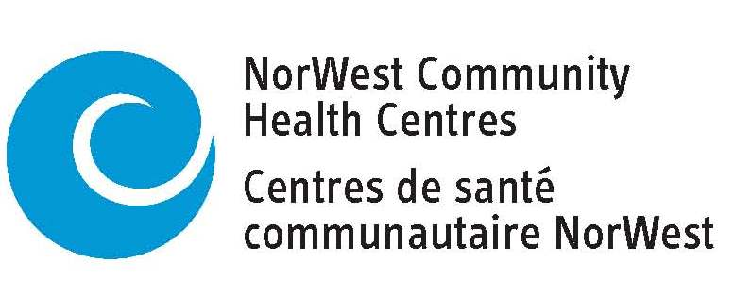 **Board Director Application**

|  |
| --- |
| NorWest Community Health Centres focuses on primary health care, prevention, and health promotion; providing care today and in the future to individuals and communities within the District of Thunder Bay. Members of the Board of Directors play a vital role in providing effective governance and strategic leadership that reflects the communities it serves and upholds the principles of equity, diversity and inclusivity. The Board of Directors hold a range of skills and experience that will lead the effective governance of the organization.  The Board operates under a Policy Governance Model and are responsible for setting strategic direction and to help NorWest Community Health Centres fulfill its vision and mission. Make a difference in our community and please submit this application or your resume. |

|  |  |
| --- | --- |
| **Contact Information** | |
| **Preferred Name:** | **Preferred Phone Number:**  **(807)** |
| **Address:** | **Email Address:** |
| **Occupation:** |  |

|  |
| --- |
| **Question and Answer** |
| Please tell us about your interest in being a Board Director at NorWest CHC: |
| Describe your education, work, community involvement, volunteer experience and lived experience and share how this would assist you in a Director role: |
| Please describe your knowledge of a Policy Governance: |
| What do you understand to be the role of a Board Director within the policy governance Board structure at NorWest Community Health Centres: |
| What do you understand to be the role of the CEO within the organization of NorWest CHC and in relation to the Board of Directors: |
| What specifically interests you about community based primary health care and the services offered by NorWest Community Health Centres: |
| The Board holds nine (9) monthly meetings. Would you be prepared to attend the monthly meetings? Yes  No    Directors participate on a minimum of one Adhoc committee. Are you prepared to participate in an Adhoc committee? Yes  No |
| Signature:       Date: |

For further information and to submit your application or resume, please contact:

Juanita Lawson, CEO at [jlawson@norwestchc.org](mailto:jlawson@norwestchc.org) or (807) 626-8482

*Upon request, accommodations due to a disability will be made available.*